Name: James Young
Date: Feb 10
15.07 Picture Lab Worksheet
Directions: Make note of your responses to the following questions as you work through the activities and exercise in the lesson.
Activity 5 Questions
Question | Yes | No
- Is the method getPixels2D in the Picture.java class? |  | x
- Is the method getPixels2D in the SimplePicture.java class? | x
- Will the following code compile?  DigitalPicture p = new DigitalPicture(); |  | x
- Assuming a no-argument constructor exists for SimplePicture, will the following code compile?  DigitalPicture p = new SimplePicture(); | x
- Assuming a no-argument constructor exists for Picture, will the following code compile?  DigitalPicture p = new Picture(); | x
- Assuming a no-argument constructor exists for Picture, will the following code compile?  SimplePicture p = new Picture(); | x
- Assuming a no-argument constructor exists for SimplePicture, will the following code compile?  Picture p = new SimplePicture(); |  | x

Activity 5 Exercise Results

- Describe your method for keepOnly red, blue, or green.
My method only keeps blue pixels by setting red and green pixels to 0.

- For the negate method, paste your code related to calculating and setting the values for red, blue, and green.
pixelObj.setRed(pixelObj.getRed() - 255);
pixelObj.setGreen(pixelObj.getGreen() - 255);
pixelObj.setBlue(pixelObj.getBlue() - 255);

- Paste a copy of the image that is the result of calling the grayscale.

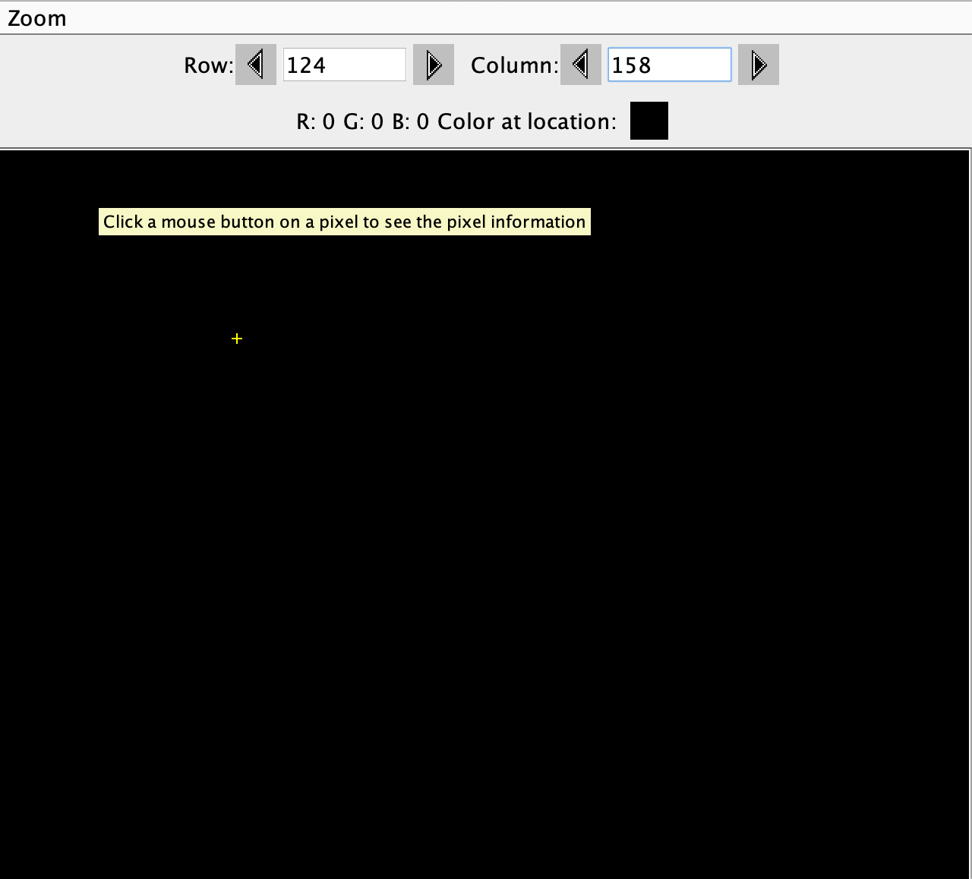

- For the method fixUnderwater, describe the algorithm you'd propose to accomplish the task.

I would obtain a sample of the fish, find the avg. value and range of color and. Then, I would calculate distance from inputted values to sample values, and adjust image based on how close sample value is to inputted value.
Activity 6 Exercise Results
- Paste the image that is the result of calling the method mirrorVerticalRightToLeft.
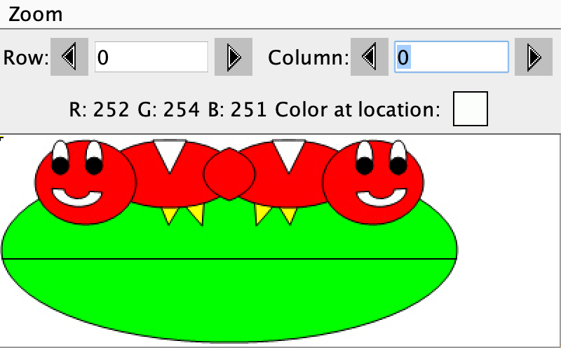
- Describe the algorithm for the method mirrorHorizontal works.
It is similar to the mirrorVertical but instead of looping through half the columns and all the rows, we loop through all the columns but half the rows .

- Paste the image that is the result of calling the method mirrorHorizontalBotToTop.
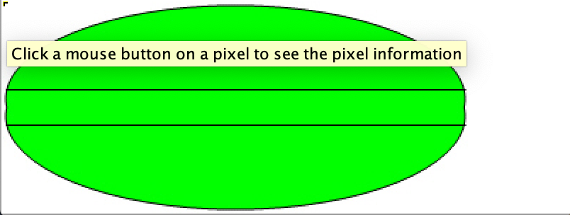
Activity 7 Questions
  - How many times would the body of this nested for loop execute? _90____
for(int row = 7; row < 17; row++)
for(int col = 6; col < 15; col++)
  - How many times would the body of this nested for loop execute? __112___
for(int row = 5; row <= 11; row++)
for(int col = 3; col <= 18; col++)

Activity 7 Exercise Results

- What value is displayed for count after the nested loop ends in the mirrorTemple method? _18410___
- Paste the image that is the result of calling the method mirrorArms.
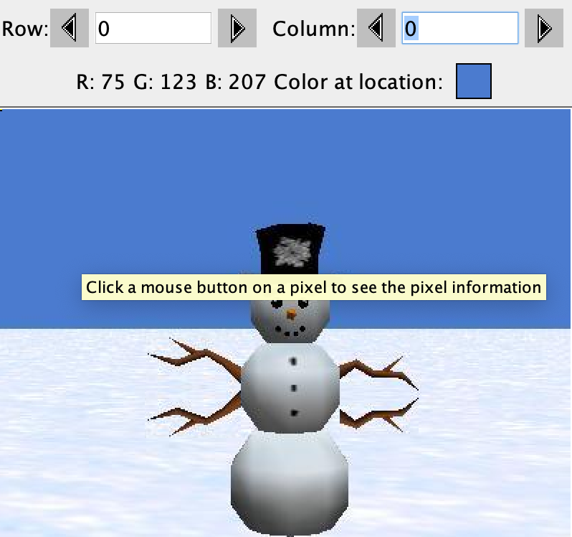

- Paste the image that is the result of calling the method mirrorGull.
